Personalized Video Bill Explanations Help You Save Energy and Money

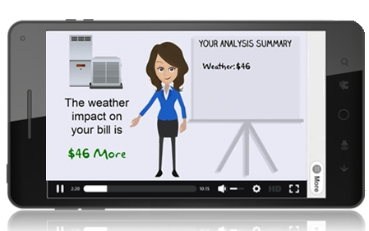
As the weather changes so does the costs to heat and cool your home, this can occasionally lead to an unexpected high bill. Understanding the impact of the weather, behavior, and days in the billing cycle can help you reduce your energy use and avoid high bills without sacrificing comfort in your home. Utility Name is always looking for ways to help our members save energy and money; we now provide a free personalized video bill explanation delivered by email if your bill increases more than a few dollars from the previous month.
Energy Analysis Just for You
Your home and family is unique and so is your energy use. These entertaining personal video messages explain your home’s energy use compared to last month using your actual billing data. If there is an increase in your energy use, the video will explain what factors may have contributed to the increase. The video will point out the impact of the local weather, number of days in the billing period broken down in easy to understand dollar amounts. The explanation also includes other factors such as guests in the home or thermostat settings. Each video will contain recommendations on how to save and keep you informed about rebate offerings and programs.
Sign Up Today!
In order to participate we will need to link an email with your account number. Call one of our representatives If applicable instructions on how to sign up to create this link. Then visit our website www.yourwebsite.com, directions on how to find and start enjoying your personalized videos today.
Go Digital
Now that you know about the personalized video bill explanation, sign up to receive paperless billing and receive your bill and video by email every month. It’s free. It’s secure and a great way to help save the environment.

